**Exhaustive analysis of Indian Agriculture using Power BI**

**Objective:** An exhaustive analysis of Indian agriculture using Power BI aims to leverage the power of data visualization and analytics to gain comprehensive insights into the state of agriculture in India. By integrating multiple data sources, Power BI enables the creation of interactive and dynamic dashboards that present agricultural trends, challenges, and opportunities across the country.

**Tools: Power BI**

**ETL:** in Power BI stands for Extract, Transform, Load and is a crucial part of the data preparation process for analytics and reporting. Power BI provides a powerful and user-friendly environment to perform ETL operations, enabling users to gather data from various sources, shape it into a desired format, and then load it for reporting and analysis.

**1. Extract (E):**

* **Data Extraction** refers to the process of pulling data from various external sources into Power BI. These sources can include databases (SQL Server, Oracle, etc.), flat files (CSV, Excel), web services, cloud platforms (Azure, Salesforce), APIs, and more.
* In Power BI, this is done using **Get Data**. The user selects the data source, enters the necessary connection details (server, database, etc.), and retrieves the data.
* **Common Extraction Sources**:
  + Databases (SQL, MySQL, PostgreSQL, etc.)
  + Excel Files
  + CSV Files
  + Cloud Data (Azure, Google Analytics, etc.)
  + APIs (e.g., REST API)
  + Web Scraping (HTML tables)

**2. Transform (T):**

* **Data Transformation** involves cleaning, structuring, and shaping the data so that it's ready for analysis. This step can include various operations, such as filtering rows, removing duplicates, adding new columns, converting data types, aggregating data, and creating calculated columns and measures.
* Power BI uses a tool called **Power Query** for data transformation. It provides a graphical interface where users can apply transformations step by step, which can later be refreshed automatically when the data is updated.

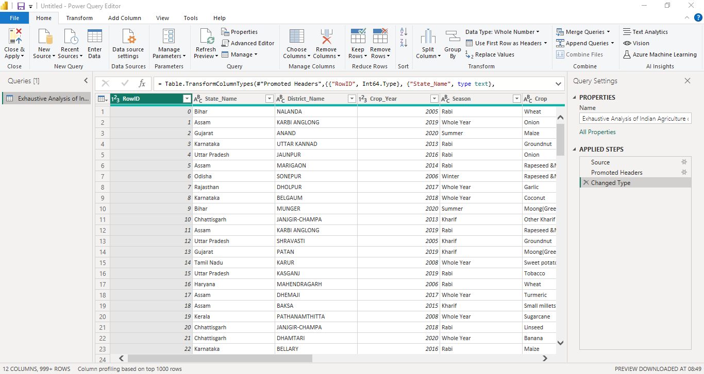

**Key Transformations in Power BI**:

* + **Filtering**: Removing unnecessary rows or columns from the data.

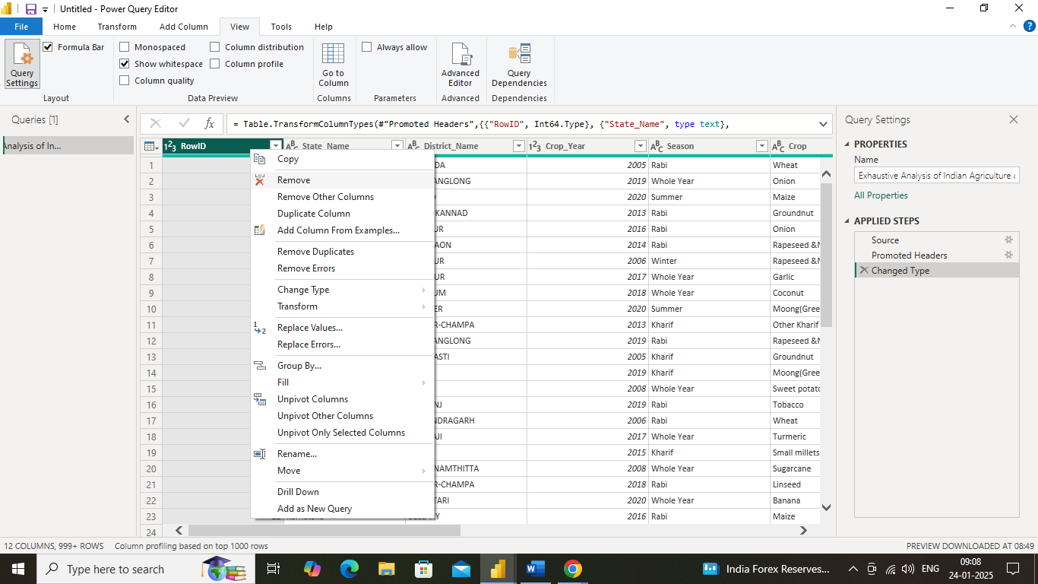

* + **Data Type Changes**: Converting data types (e.g., changing a column from text to date).

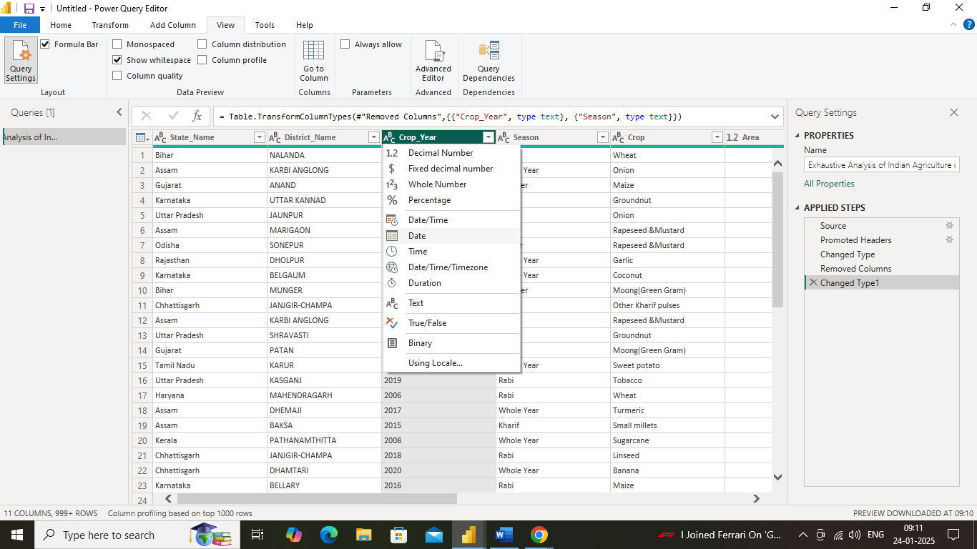

* + **Removing empty** :(or null) values is a common data cleaning

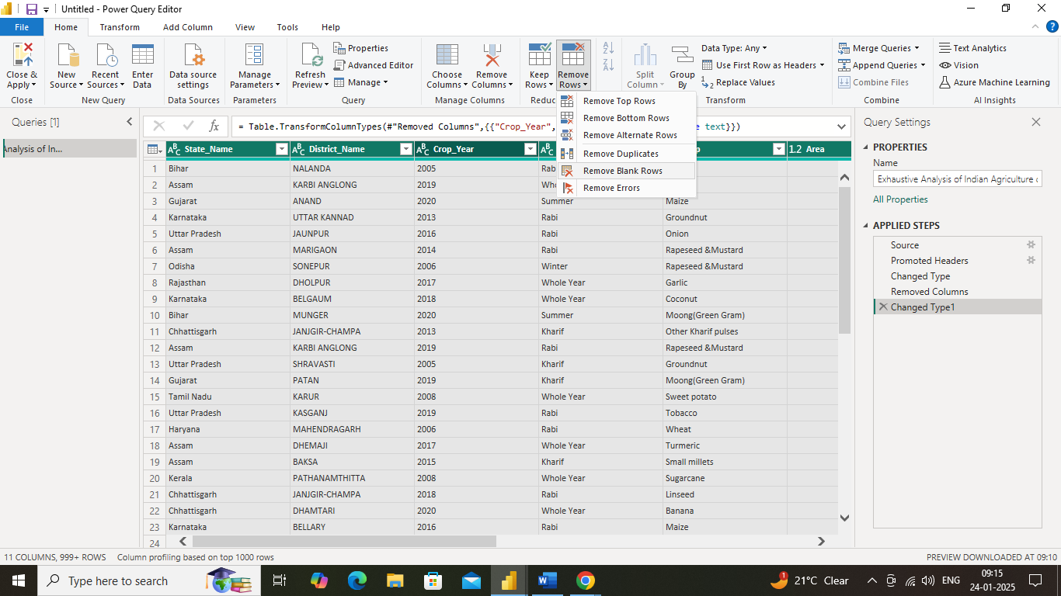

**3. Load (L):**

* **Loading** is the final stage where the transformed data is loaded into the Power BI data model for further analysis and visualization. Once the data has been cleaned and structured, it is loaded into **Power BI’s in-memory data model**.

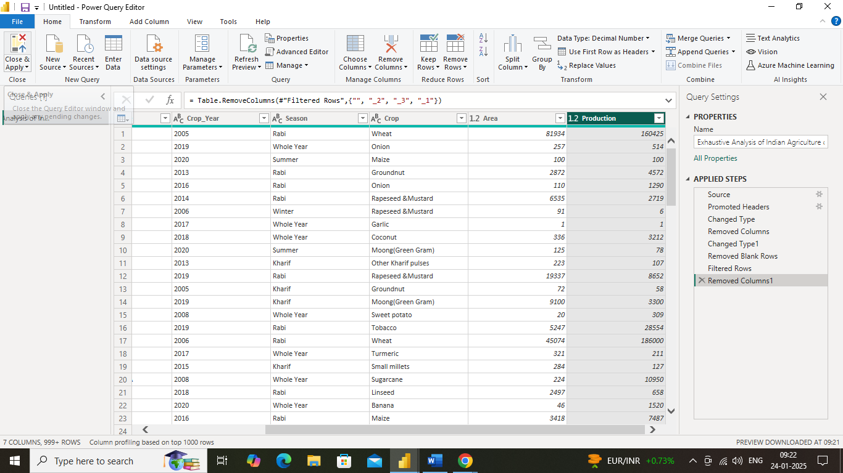

**Table view of loaded data:**

